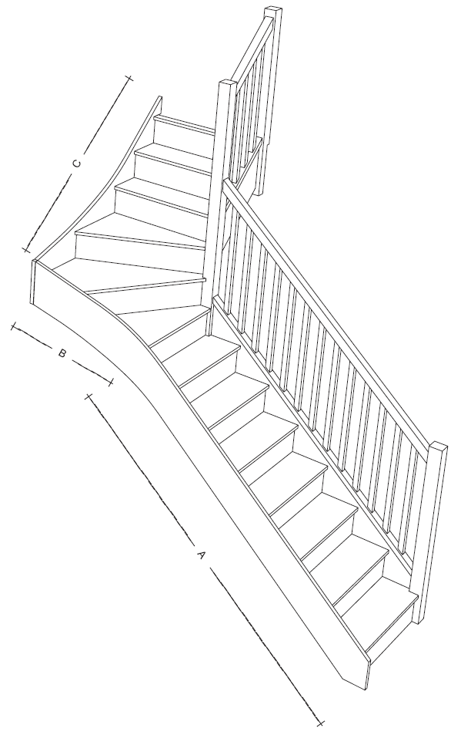
Winder – Right (4)

If this Diagram matches the site, please mark up dimensions; tick the appropriate box for the type of wall. Then forward a copy of this diagram to Medequip.
Rails and Minor Adaptations
Requisition Number:
Pin Number:
Client Name:
Client Address:

Dimensions

Rail | Length | Height | Hollow Wall | Solid Wall
A
B
C
D
E
F

